Newsletter Draft Text

Please adapt the text as you like to suit your newsletter.

*************************************************************************************************************

Experts release ‘Eight Investments That Work for Physical Activity’ to enable everyone, everywhere, to be physically active

The International Society for Physical Activity and Health (ISPAH) has released the #8Investments, providing a concise roadmap for investment and action to promote physical activity around the world.

ISPAH’s call to action is for everyone, everywhere, including professionals, academics,
civil society and decision makers, to embed physical activity in national and subnational policies.

The full document and associated resources can be accessed here: https://www.ispah.org/resources/

ISPAH President, Professor of Active Living Environments at the University of Southern Denmark, Jasper Schipperijn commented “Globally, one in four adults and four in five adolescents are insufficiently active, accounting for more than five million deaths annually. It costs the global economy billions of dollars.” You can read more from the ISPAH President in the media release, available via: https://www.ispah.org/resources/

ISPAH’s #8Investments complements the World Health Organization Global Action Plan for Physical Activity 2018-2030, assisting communities and countries looking to respond to the physical inactivity pandemic.

The #8Investments provides a summary of eight areas for action which are supported by scientific evidence and have worldwide applicability.

Readers call to action: You can advocate for a more physically active world by reading, sharing and endorsing the #8Investments document, which can be accessed here www.ispah.org/resources along with a suite of resources to support your advocacy efforts.

Join the conversation by engaging with ISPAH and our global community online on Facebook, Twitter and LinkedIn and share your stories of engagement using the #8Investments.

*************************************************************************************************************

Images

Banner (1500 X 500px)
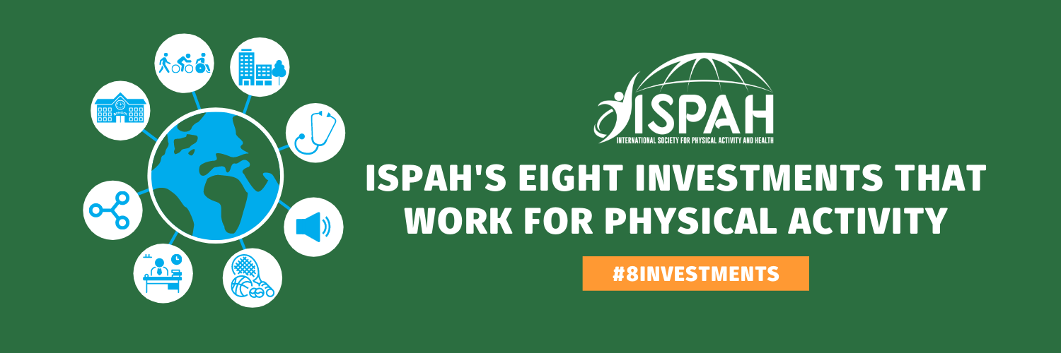

Rectangular (1600+900px)

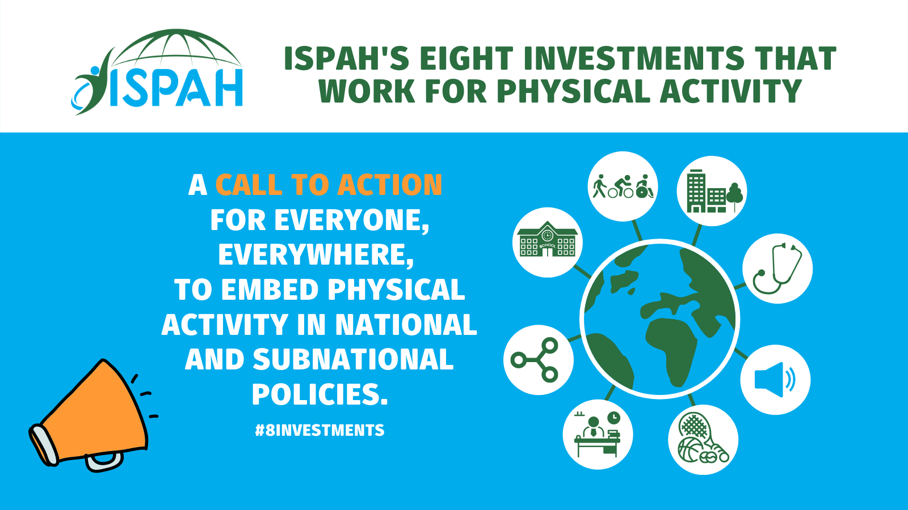

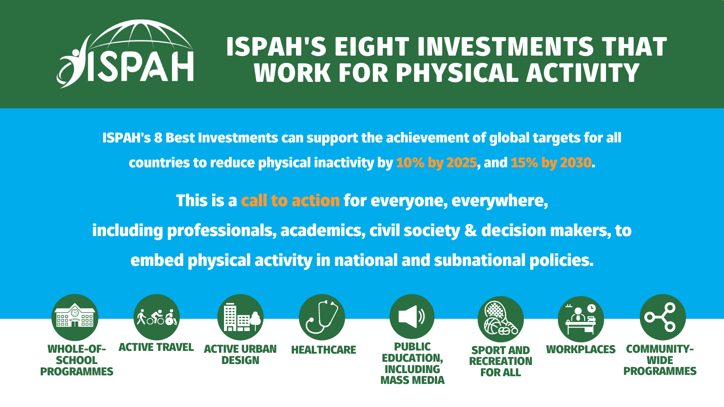
Additional Resources

If applicable, you may also like to use some of the other #8Investments images that can be found within the Advocacy Kit at www.ispah.org/resources for your newsletter.

